A Brief History of the Negev Bedouin
The changes of the twentieth century have brought about the destruction of many indigenous communities, as is happening today to the Bedouin community in the Israeli Negev. Today in the southern Negev desert of Israel there exist 45 Bedouin villages with a combined population of more than 70,000 people, all citizens of the state of Israel. They live in communities that appear on no official maps, and receive no basic and essential services from the Israeli government, such as electricity, water, sewage, paved roads, and inadequate medical services. They are the most impoverished sector of Israeli society. These 45 villages are referred to as unrecognized, denoting the willful disregard the government employs when dealing with the Bedouin population. This situation has existed for the 60 years of Israel's existence, and Israel has made, and continues to make, policy decisions to ensure that Bedouin land is confiscated without hope of return, and the grave conditions of the unrecognized villages remain in place. Under the guise of 'civilizing the Arabs,' Israel has created a situation that is untenable, and demands a comprehensive and just solution which recognizes the right of the Bedouin to live on their own land in dignity and with respect to their basic rights to adequate housing, water, and the services afforded other citizens.

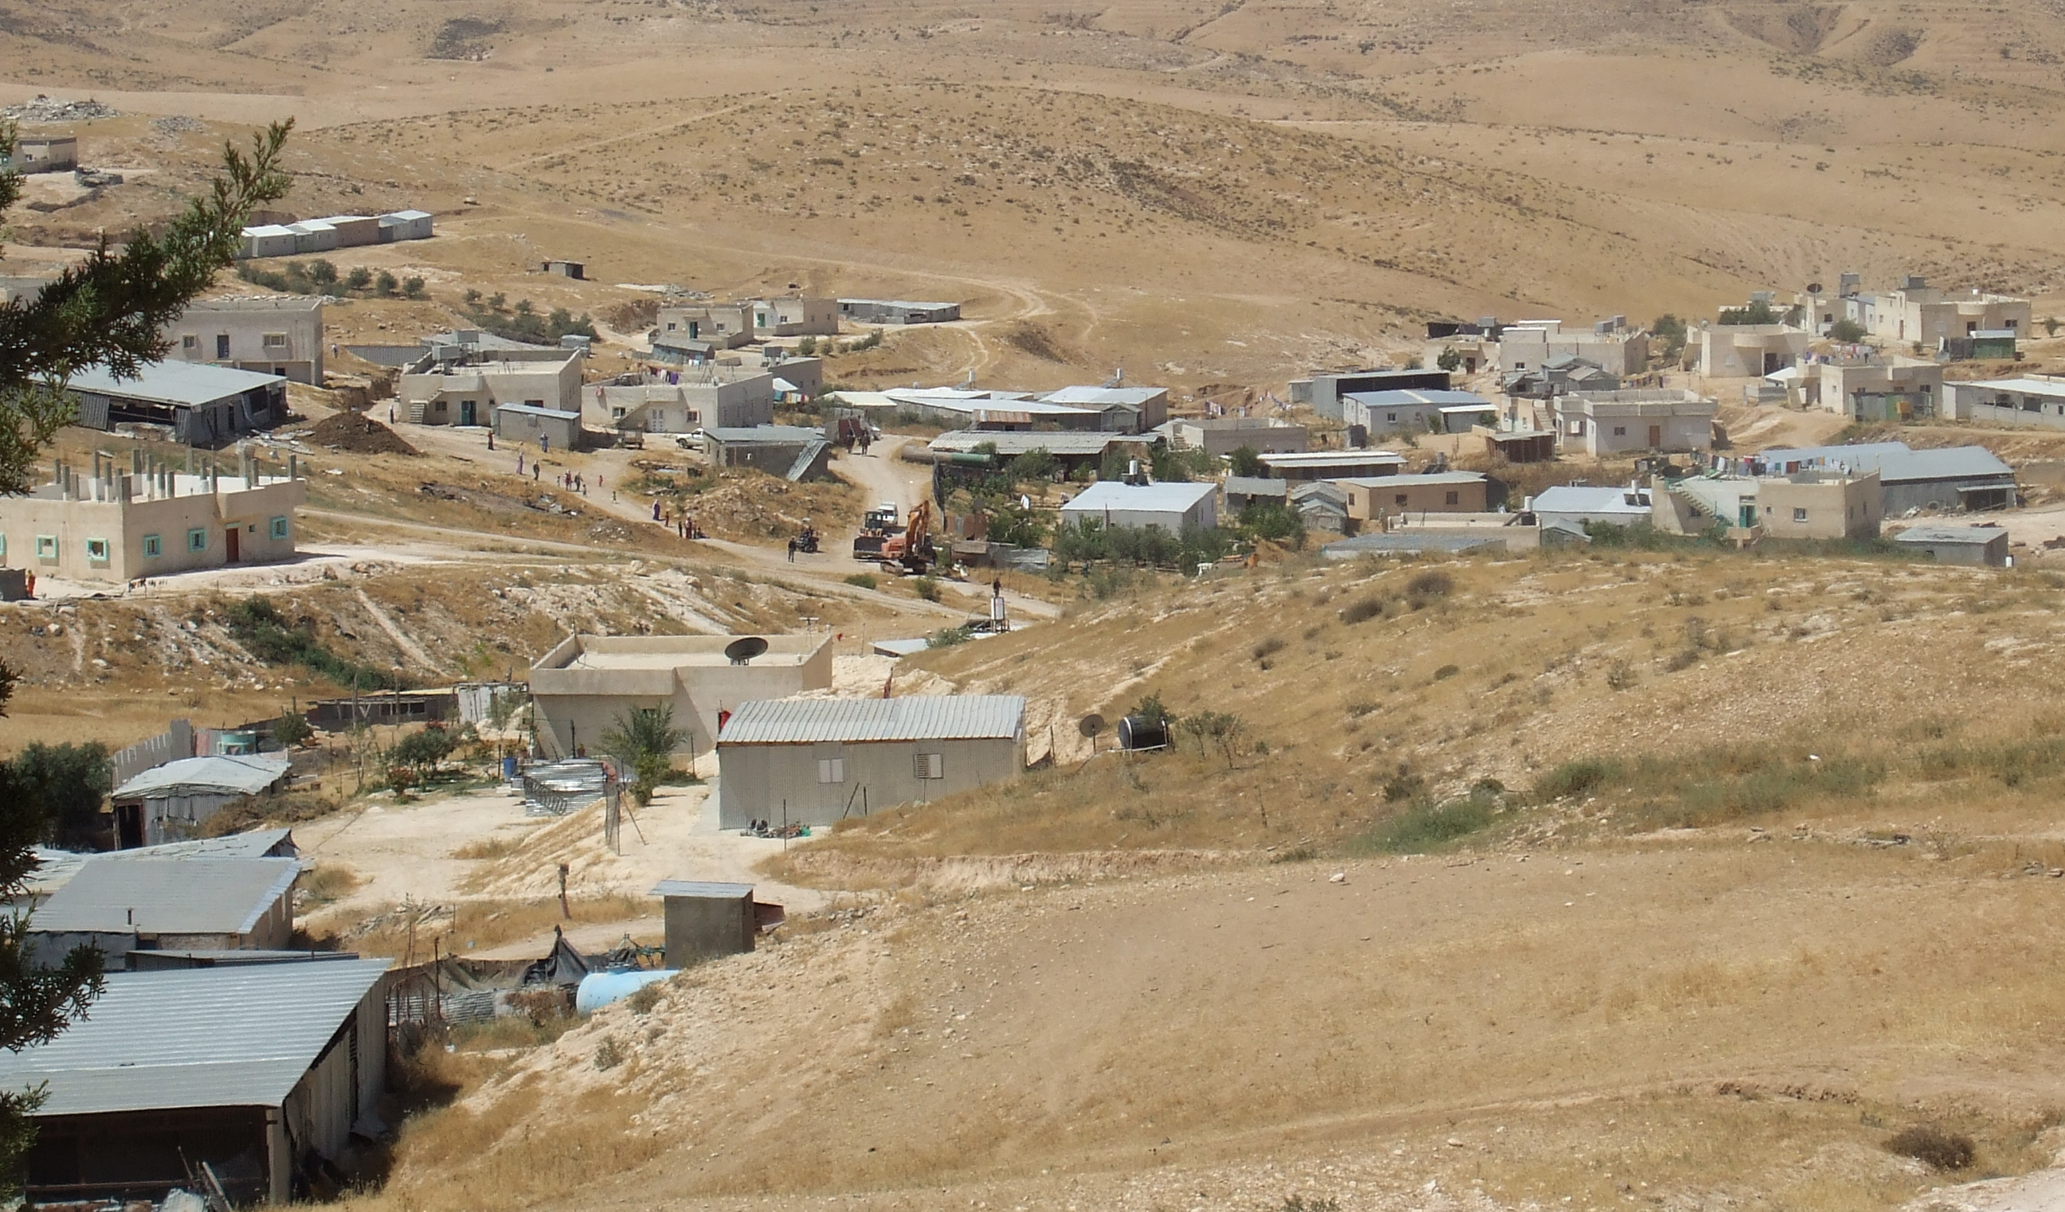
Part of the unrecognized Arab-Bedouin village of Atir. The bulldozer in the center has just completed a home demolition in the top left corner of the photo.

Brief History
The Bedouin people are the indigenous inhabitants of the Negev desert, arriving in waves from the Arabian Peninsula over the last hundreds and thousands of years. Since that time, the Bedouin population has been residing in the region in semi-nomadic communities, depending primarily on their livestock as a means of survival, and developing a culture distinct from other Palestinian communities in the North. This community has, for its entire existence, retained a high degree of self-reliance and autonomy.
One can divide modern Bedouin history into four distinct periods, and with each period came erosion of this autonomy and land rights, ultimately culminating in the situation we have today. They are, respectively, the Ottoman period, the British mandatory period, Israeli rule from 1948-1966, and Israeli rule from 1966 to the present. During the later part of the Ottoman period, many of the Bedouin began cultivating land, and consequently a private land ownership system was established and regulated by the Bedouin courts. During this time the Negev was nominally under the dominion of the Ottoman Empire, yet their authority was regarded by the Bedouin with disdain and distrust. When the Ottoman Land Law (1858) came into effect and required all subjects to register their land and pay the necessary taxes on it, many Bedouin ignored the law. The reasoning was that land ownership was already recognized by the Bedouin community, so there was no need to claim it on paper. In addition, Bedouin had little interest in paying taxes to an occupying foreign force. However, this decision came back to wreak havoc on Bedouin rights to land, almost a hundred years later. With few Bedouin still possessing an original Tabu, or Ottoman land deed, the Israeli authorities could argue that no land claim ever in fact existed.
With the dissolution of the Ottoman Empire following World War I the Bedouin welcomed a brighter future, having fought on behalf of the British and believing British promises of Arab autonomy. The British instigated a massive land registry system, which once more the Bedouins either chose to ignore, or were oblivious of it. However, the colonial secretary issued a statement recognizing Bedouin land claims in the Negev according to Custom Law, and in fact this statement is used as precedent when advocating for Bedouin land rights.
During the 1948 war, as the State of Israel was created, most of the Bedouin either fled or were driven out of the Negev to neighboring countries. Of about 70,000 Bedouin before the war only 11,000 remained, typically those tribes who were loyal to the new state. Their leaders swore loyalty to the state of Israel, they all and adopted Israeli citizenship, in return for a promise to allow them to continue with their traditional way of life and maintain use of their lands. Despite these promises during the 1950s the Bedouin who remained were concentrated into an enclosed triangular region known as the Siyag, or enclosure in Hebrew, with today’s towns of Arad, Yeruham and Rahat forming the points of this triangle. This created two types of villages: those who were in the Siyag area before 1948, living on their traditional lands, and newcomers, in villages now created by the state, living as ‘guests’ on the local Bedouin lands. The Bedouin population was put under Military Rule, ending only in 1966. During this period more than 85% of Negev land was declared state land, effectively confiscating it wholesale from the Bedouin.
In 1965 Israel passed the Planning and Building Law, which regulates the process of applying for building permits. This law ignored the existence of the Bedouin community, not recognizing their villages as formal entities, thus making it impossible to receive building permits in the villages they were residing. This is the state of affairs until this day: still there exists no method of attaining a building permit for a Bedouin village, and so all houses in the villages are ruled illegal and are under constant threat of demolition.
During this period the government also imposed severe grazing restrictions on the Bedouin, further reducing their ability to continue with their traditional lifestyle and livelihood. The government passed a law called the Black Goat Law in 1950, prohibiting the grazing of black goats, the main grazing animal of the Bedouins, and the one most suited for the desert conditions. Since the black goat's hair was used to weave tents, without access to grazing land, the black goat disappeared, as did the practice of weaving tents. Today the black goat is nearly extinct from the region, and the cultural tradition of tent-weaving has died with it.

Urbanization
Military rule ended in 1966, and a new policy towards the Bedouin was adapted: coerced urbanization. The goal of this new approach is turn the Bedouin into an 'urban proletariat,' as prophesized by Moshe Dayan in 1963:
“We should transform the Bedouin into an urban proletariat - in industry, services, construction, and agriculture... This will be a revolution, but it can be achieved in two generations. Without coercion but with governmental direction ... this phenomenon of the Bedouins will disappear"

This plan came into action with newly-created towns with dense urban planning. The first township was Tel Sheva, adjacent to Beer Sheva, in 1969, and another six were established by the mid 1990’s. The townships, in addition to focusing a large number of Bedouin on a small amount of land, also contributed to a breakdown of traditional Bedouin social structure by combining many different tribes and clans in one city. Further, there is no room inside the city for livestock, considered essential to Bedouin livelihood and identity. These cities currently have the highest rate of unemployment in Israel, as well as extremely high crime rates stemming also from lack of viable job options in the towns. The largest of the townships, Rahat, was founded in 1972 and declared a city in 1994, and is the only Bedouin city in Israel. Segev Shalom was founded in 1979, Lakiya, Arara, and Kuseife in 1982, and Hura was founded in 1990. Of the 180,000 Bedouin currently living in the Negev, about half live in these “concentration” towns.
The concentration of Bedouin in townships was presented in a carrot-and-stick arrangement: on one hand, the townships offered cheap land for housing and services such as electricity, water, and roads. Further, it presented an opportunity for the Bedouins who were still uninvited guests on others’ lands in the Siyag to move to unclaimed lands. On the other hand, the unrecognized villages had no services and were subject to the threat of demolition of property. Many Israeli officials therefore declared, and continue to declare to this day, that living in the unrecognized villages is a choice, and that ample opportunities have been provided for the residents to improve their situation. These statements ignore the fact that a) most of the Bedouin settlements within the Siyag pre-date the state of Israel; and b) those that don't are internally displaced refugees and are in place as a result of Israeli expulsions. Furthermore, to move to a town is to give up one's identity, livelihood, land, community, and social safety and stability.
In 1947 the Bedouins exclusively owned and used 99% of the Negev lands. Today the entire land used by the Bedouins for homes and agriculture consist of 3% of the Negev lands, claiming historical ownership of another 5%, while having no access to these additional lands. Today the Bedouin population is over 25% of the Negev population. 70% of the Bedouin community today lives below the poverty line – a direct result of governmental policies. Deplorably, the battle the Government of Israel is waging against this poor and disenfranchised community is over a small portion of desert land.

The day-to-day meaning of non-recognition.
An unrecognized village is a village that does not officially exist, as such does not have a local building plan, which is a prerequisite for any infrastructure. Further, it has no municipality. No infrastructure means there are no water pipes to the homes, electricity is not supplied from the national grid, there are no phone lines, and it is illegal to build any roads. Services provided by local municipalities include also trash removal, sewer systems and schools, lacking a municipality, these services are not provided. Further, as these villages do not officially exist, there is no imperative to provide medical clinics in the villages. The worst, however, is that there is no way in which to acquire a building permit, thus all homes are rendered illegal and are under the threat of demolition.
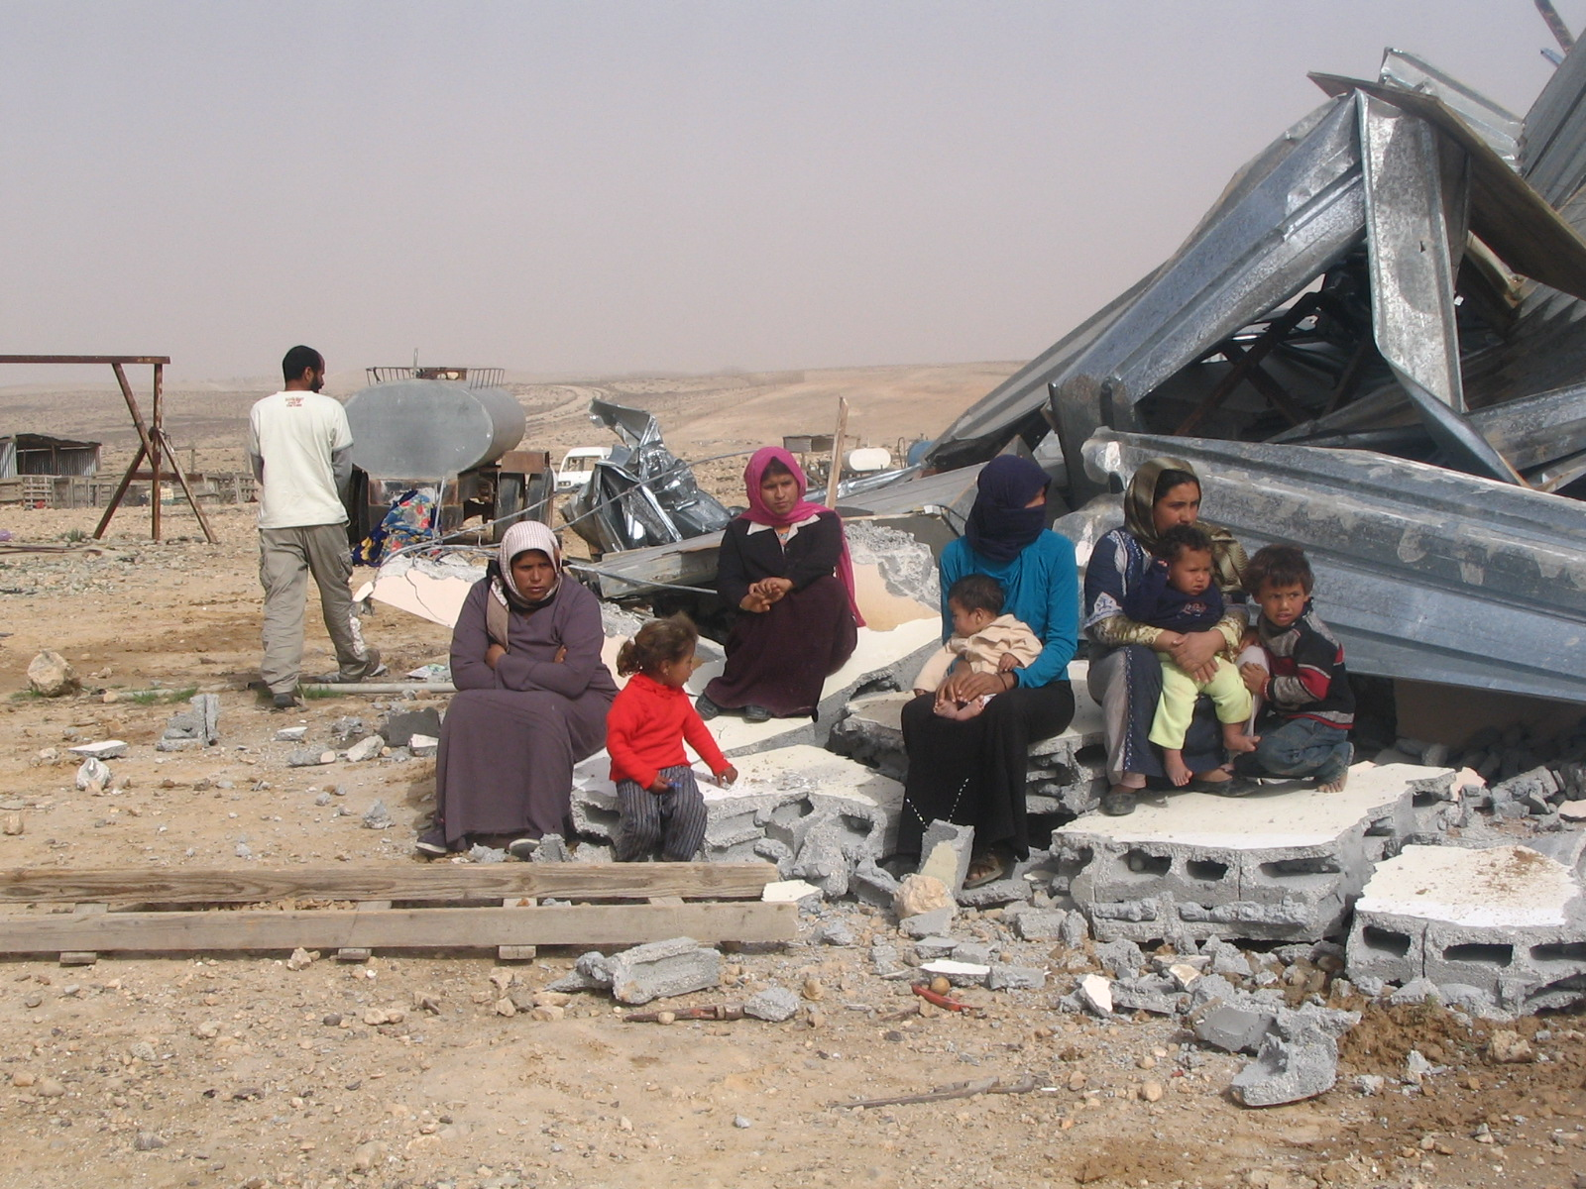
Family sitting on the ruins of their home, in unrecognized village in the Negev.

The homes are typically built of corrugated iron; or with brick walls, no foundations, and a corrugated iron roof. This is because corrugated iron is the cheapest building material. In addition the government is more likely to demolish a more enduring structure, so for fear of demolitions, the population lives in tin homes. Further, since many homes are demolished, the cheapest building material allows families to re-build in the case of home demolitions. In 2007 alone the Government of Israel demolished 228 homes in the unrecognized villages. These tin homes become extremely hot in the summer and very cold in the winter, harming the health of the families. Also without access to electricity, the only means of heating the houses is an open fire, exasperating the health hazards.

Current Developments: Abu Basma Regional Council, the Goldberg Commission, the New Authority for the Settlement of the Bedouins, and the Praver Commission.
As a result of the lobbying efforts of the community and civil society organizations, the Government of Israel gradually recognized eleven villages over the last seven years. These villages have been put under the jurisdiction of the governmentally appointed Abu Basma Regional Council. As foreseen, this has been so far a failure, as while the government recognized the existence of the villages, it has still refused to recognize the traditional personal land claims of the villagers. Therefore there has been a stalemate in all planning procedures, with the government claiming ownership of all lands, and therefore the right to distribute them at will, and an absolute refusal of the villagers to this en-mass confiscation of their lands. Therefore the villages of Abu-Basma Regional Council remain as do the remainder of the unrecognized villages – with no infrastructure, no services and no building permits.
Faced once more with a dead-end situation, the Government of Israel appointed a public commission headed by former supreme-court judge Goldberg, “The Goldberg Commission”, to conduct public hearings and articulate a solution to the unrecognized villages, taking into consideration the issue of traditional Bedouin land ownership claims. The commission submitted its recommendations on November 2008, and these were accepted by the government of Israel in January 2009. Unfortunately, the commission’s recommendations do not change in any meaningful way the policies of the government towards the Bedouin.
To implement the recommendations of the Goldberg commission, two new bodies have been established: the New Authority for the Settlement of the Bedouin, headed by former police commissioner Yehuda Bahar; and yet another commission, The Praver Commission, in order to create an implementation plan for the Goldberg recommendations. The Praver plan is complete and waiting for the approval of the Government of Israel, in order to pass legislation and to be implemented. In the meantime the Government has allocated very large sums of money for the implementation of the Praver plan. While we have not had access to the Praver plan, we do know that it includes the planned erasure of about 20 Bedouin villages, of around 1,500 residents each. This can be achieved only with extreme violence, as we are experiencing already in the attempted erasure by the Government of Israel of the historical Bedouin villages of El-Araqib and Twail Abu-Jarwal.
The community is still facing a harsh upward battle in order to achieve any rights in the near future.

Dr. Yeela Raanan
I was born and brought up in the Israeli Negev, an Israeli Jew. I received my Ph.D. in Anthropology from the University of Utah (USA). I have been involved in the Arab-Bedouin struggle for civil, human and indigenous rights since the completion of my studies and my return to Israel ten years ago. As a resident of the Negev, for me, as long as my Bedouin-Arab neighbors suffer from violations of their rights, I cannot feel free to enjoy those privileges provided for me as one of the dominant group – the Jews in Israel.
For more information: Dr. Yeela Raanan. yallylivnat@gmail.com

